Chiang Mai Yi Peng Lantern Festival

Yee Peng Festival in Chiang Mai (sometimes written as ‘Yi Peng’) is celebrated on the full moon of the twelfth lunar month ever year, which normally means mid-way through November, but this can vary. The Yee Peng lantern festival is held in November every year.

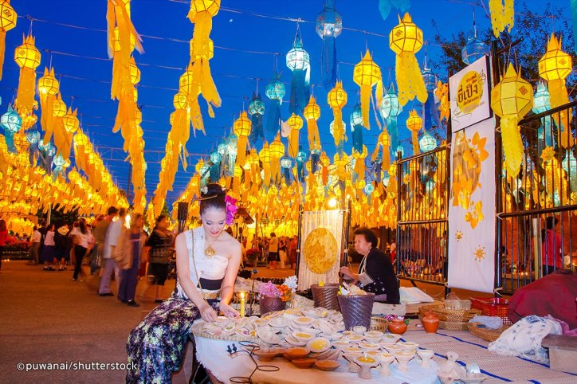

In Chiang Mai, Loy Krathong is preceded by Yee Peng (The Lantern Festival), during which people release floating lanterns into the sky. It is during Yee Peng that you see locals' homes and public places decked out in colourful hanging lanterns and flag decorations. The act of releasing the lantern and krathong symbolizes letting go of all ills and misfortunes in the previous year, and Buddhists also believe that if you make a wish when you set off the lantern, it will come true (but only if you do good deeds the following year, of course).

As part of this festival of lights, there are plenty of other activities that happen all over Chiang Mai. These include traditional Thai dance shows, the official ‘Yee Peng Parade’ around the Old City gate and down Tha Phae Road, live music and handicraft sessions.  
  
You can also expect lots of food vendors setting up, firecrackers, fireworks, and hordes of tourists with selfie sticks (particularly around the Tha Phae Gate area).

**Where to Celebrate Yee Peng Festival in Chiang Mai**

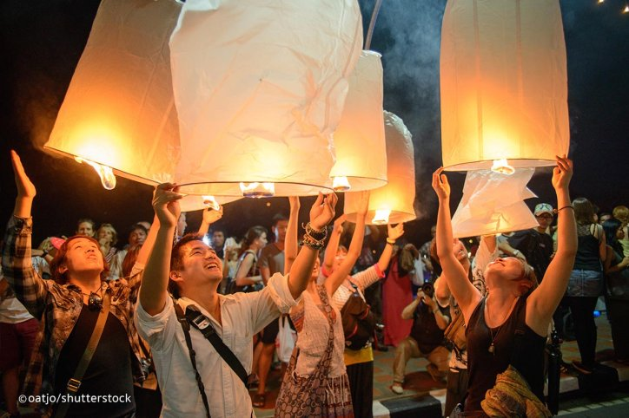

Lanterns are released into the sky all over Chiang Mai during the night, but for that spectacular photo op (when everybody releases the lanterns at the same time), the best place to head is Mae Jo University for the big release at 18.30. Do note that you should arrive well in advance of this time to get a good spot. Remember to wear respectable clothing (no skimpy shorts or tees).  
  
There is also another Yee Peng ceremony especially set up for tourists, held about one week after the actual festival. It involves more mass lantern lighting and spectacular photo opportunities. Tickets in the past have been $US100 (around 3,000 baht), and this has included a full meal, transfers and two lanterns… the whole package basically. The location and dates are not confirmed until closer to the date, around the end of November.